**PARADISE ISLAND BEACH CLUB**

Financial Statements for the Year Ended December 31, 2017

And Independent Auditors’ Report

**PARADISE ISLAND BEACH CLUB**Financial Statements

Years ended December 31, 2017 and 2016

|  |  |
| --- | --- |
|  | Page |
|  |  |
| Independent Auditors’ Report | 1 |
|  |  |
| Statement of Financial Position | 2 |
|  |  |
| Statement of Comprehensive Income | 3 |
|  |  |
| Statement of Changes in Equity | 4 |
|  |  |
| Statement of Cash Flows | 5 |
|  |  |
| Notes to Financial Statements | 6–22 |

**INDEPENDENT AUDITORS’ REPORT**

***To the Shareholder of Paradise Island Beach Club:***

We have audited the accompanying financial statements of Paradise Island Beach Club, which comprise the statement of financial position as of December 31, 2017, and the statements of comprehensive income, changes in equity, and cash flows for the year then ended, and a summary of significant accounting policies and other explanatory notes.

***Management’s responsibility for the financial statements***

Management is responsible for the preparation and fair presentation of these financial statements in accordance with International Financial Reporting Standards, and for such internal control as management determines is necessary to enable the preparation of financial statements that are free from material misstatement, whether due to fraud or error.

***Auditors’ responsibility***

Our responsibility is to express an opinion on these financial statements based on our audit. We conducted our audit in accordance with International Standards on Auditing. Those Standards require that we comply with ethical requirements and plan and perform the audit to obtain reasonable assurance about whether the financial statements are free from material misstatement.

An audit involves performing procedures to obtain audit evidence about the amount and disclosures in the financial statements. The procedures selected depend on the auditors’ judgment, including the assessment of risks of material misstatement of the financial statements, whether due to fraud or error. In making those risk assessments, the auditor considers internal control relevant to the entity’s preparation and fair presentation of the financial statements in order to design audit procedures that are appropriate in the circumstances, but not for the purpose of expressing an opinion on the effectiveness of the entity’s internal control. An audit also includes evaluating the appropriateness of accounting policies used and the reasonableness of accounting estimates made by management, as well as evaluating the overall presentation of the financial statements.

***Unqualified Opinion***

In our opinion the financial statements present fairly, in all material respects, the financial position of Paradise Island Beach Club as at December 31, 2016, and its financial performance and its cash flows for the year then ended in accordance with International Financial Reporting Standards.

***Roshan Noronha***

**Chartered Accountants**

**March 15, 2018**

**PARADISE ISLAND BEACH CLUB**Statement of Financial Position

December 31, 2017 and 2016  
(Expressed in Bahamian dollars)

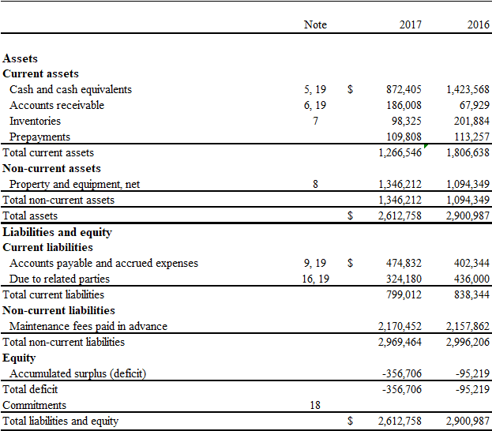

See accompanying notes to financial statements.

These financial statements were approved by the Management Committee on March 15, 2018 and signed on behalf of the Management Committee by:

____________________________ ________________________  
James Martens Robert (Bob) Groff

Nominated Member – Chairman Elected Member

**PARADISE ISLAND BEACH CLUB**Statement of Comprehensive Income

December 31, 2017 and 2016

(Expressed in Bahamian dollars)

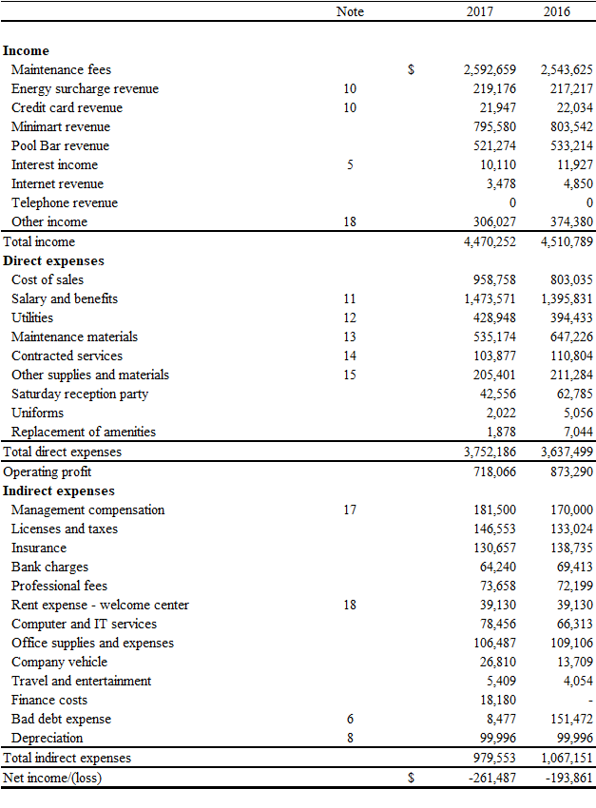  
See accompanying notes to financial statements.

**PARADISE ISLAND BEACH CLUB**Statement of Changes in Equity

December 31, 2017 and 2016  
(Expressed in Bahamian dollars)

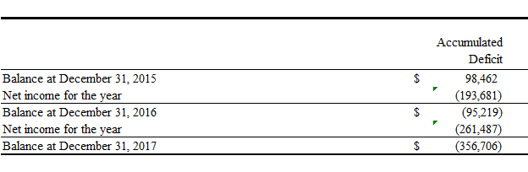

See accompanying notes to financial statements.

**PARADISE ISLAND BEACH CLUB**Statement of Cash Flows

December 31, 2017 and 2016  
(Expressed in Bahamian dollars)

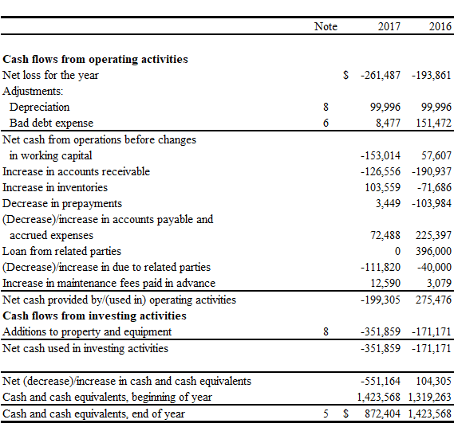

See accompanying notes to financial statements.

**PARADISE ISLAND BEACH CLUB**Notes to Financial Statements

Years ended December 31, 2017 and 2016  
(Expressed in Bahamian dollars)

1. **General information**

Paradise Island Beach Club (“the Club”) is a forty-four unit timeshare resort located on Paradise Island, Bahamas which was developed in 1984 by Paradise Island Development Ltd. (“PIDL” or “Founder Member”). The Founder Member is a wholly owned subsidiary of Paradise Island Beach Club Limited (“PIBCL” or “Landlord”) having its registered office at first floor, Claughton House Shirley & Charlotte Street, Nassau, Bahamas.

The property on which the Club was developed was conveyed by PIDL to CIBC Trust Company Bahamas Ltd to be held in trust until December 31, 2028 as assurance for purchasers of timeshare units that the property could not be encumbered. The term of the Trust was extended until December 31, 2032 to accommodate a longer than anticipated sell-out. The trust was transferred from CIBC Trust Compnay Bahamas Ltd to Butterfield Bank (Bahamas) Ltd. (formerly “Thorand Bank & Trust Ltd.”) on June 2, 2003. At the end of the trust period, the property will revert to Landlord.

The Club is a non-profit-making entity whose objective is to secure for the members joint rights of use of the timeshare units.

PIDL sold vacation certificates for each of the forty-four units which gave the purchaser/member the right to occupy a unit for one week per year (out of possible fifty weeks) for a total of forty years. Each member is obligated to pay their annual member’s dues prior to being allowed to make a reservation to occupy a unit.

Under the Constitution of the Club (“the Constitution”), the affairs of the Club shall be managed by a Management Committee of 5 individuals, 3 of whom are nominated by the Founder Member and 2 shall be members of the Club. PIBC Management Ltd. (“PIBCML”), incorporated on September 27, 2007, was formed to provide management services to the Club under an agreement dated November 14, 2007. The Club operates a mini-mart, restaurant and pool-bar, all of which are located on the premises of the Club. All relevant business and trade licenses are in the name of PIBCML.

**2. Adoption of New And Amended International Financial Reporting Standards And International Accounting Standards**

In the current year, the Club has adopted all of the new and revised standards and interpretations issued by the International Accounting Standards Board (the “IASB”) and the International Financial Reporting Interpretations Committee (the “IFRIC”) of the IASB that are relevant to its operations and effective for accounting periods beginning on January 1, 2017.



The adoption of these standards and interpretations did not have a material impact on the Club’s financial statements.

At the date of authorization of these financial statements, the following relevant standards and interpretations were in issue but not yet effective:

**2. Adoption of New And Amended International Financial Reporting Standards And International Accounting Standards, Continued**



Management has not assessed whether the relevant adoption of these standards and interpretations in future periods will have a material impact on the financial statements of the Club.

**3. Significant accounting policies**

*(a) Statement of compliance*

These financial statements have been prepared in accordance with International Financial Reporting Standards.

*(b) Basis of preparation*

These financial statements have been prepared on the historical cost basis, except where otherwise disclosed.

Historical costs are generally based on the fair value of the consideration given in the exchange for goods and services.

Fair value is the price that would be received to sell an asset or paid to transfer a liability in an orderly transaction between market participants at the measurement date, regardless of whether that price is directly observable or estimated using another valuation technique. In estimating the fair value of an asset or a liability, the Group takes into account the characteristics of the asset or liability if market participants would take those characteristics into account when pricing the asset or liability at the measurement date.

Fair value for measurement and/or disclosure purposes in these consolidated financial statements is determined on such a basis, except for share-based payment transactions that are within the scope of IFRS 2, leasing transactions that are within the scope of IAS-17,and measurements that have some similarities to fair value but are not fair value, such as net realizable value in IAS 2 or value in use in IAS 36.

In addition, for financial reporting purposes, fair value measurements are categorised into Level 1, 2 or 3 based on the degree to which the inputs to the fair value measurements are observable and the significance of the inputs to the fair value measurement in its entirety, which are descried as follows:

-Level 1 inputs are quoted prices (unadjusted) in active markets for identical assets or liabilities that the entity can acess at the measurement date:

-Level 2 inputs, other than quoted prices included within Level 1, that are observable for the asset or liability, either directly or indirectly: and

-Level 3 inputs are unobservable inputs for the asset or liabiity.

*(c) Functional and presentation currency*

These financial statements are presented in Bahamian dollars which is the functional and reporting currency of the Club. The Bahamian dollar is the prime currency of the country where the Club operates.

1. **Significant accounting policies, Continued**

*(d) Use of estimates and judgment*

The preparation of financial statements requires management to make judgments, estimates and assumptions that affect the application of accounting policies and the reported amounts of assets, liabilities, income and expenses. Actual results may differ from these estimates.

Estimates and underlying assumptions are reviewed on an ongoing basis. Revisions to accounting estimates are recognized in the period in which the estimates are revised and in any future periods affected.

Information about critical judgments in applying accounting policies that have the most significant effect on the amounts recognized in the financial statements is included in the following notes:

Note 6 Accounts receivable

Note 7 Inventories

Note 8 Property and equipment, net

Note 19 Financial instruments and associated risks

Following is a summary of the significant accounting policies which have been applied consistently by the Club in preparing these financial statements.

*(a) Financial instruments*

Classification

Financial instruments include financial assets and financial liabilities. Financial assets that are classified as loans and receivables include cash held with banks, term deposits and accounts receivable. Financial liabilities that are not at fair value through profit or loss include accounts payable and accrued expenses and due to related parties.

Recognition

The Club recognizes financial instruments initially at the trade date, which is the date when it becomes a party to the contractual provisions of the instruments.

Measurement

Financial instruments are measured initially at fair value plus, in the case of a financial asset or financial liability not at fair value through profit or loss, transaction costs that are directly attributable to the acquisition or issue of the financial asset or financial liability.

Transaction costs on financial assets and financial liabilities at fair value through profit or loss are expensed immediately, while on other financial instruments they are amortized.

**3. Significant accounting policies, Continued**

Subsequent to initial recognition, financial assets and financial liabilities not at fair value through profit or loss are carried at amortized cost using the effective interest method, less, in the case of financial assets, impairment losses, if any.

Derecognition

The Club derecognizes a financial asset when the contractual rights to cash flows from the financial asset expire or it transfers the financial asset.

The Club derecognizes a financial liability when the obligation specified in the contract is discharged, cancelled or expired.

*(b) Cash and cash equivalents*

Cash and cash equivalents comprise cash on hand and cash held with banks including term deposits having maturity of three months or less.

*(c) Accounts receivable*

Accounts receivable are stated at amortized cost net of allowance for doubtful accounts.

*(d) Inventories*

Inventories are stated at the lower of cost and net realizable value. Cost is determined using the first in first out (“FIFO”) method and includes expenditure incurred in acquiring the inventories, production costs and other costs incurred in bringing them to their existing location and condition. Net realizable value is the estimated selling price in the ordinary course of business, less the estimated costs of completion and selling expenses.

*(e) Property and equipment*

Items of property and equipment are carried at cost less accumulated depreciation and impairment losses.

Cost includes expenditure that is directly attributable to the acquisition of the asset.

When parts of an item of property and equipment have different useful lives, they are accounted for as separate items (major components) of property and equipment.

Assets are capitalized during the year as determined by the Management Committee. The costs of the day-to-day servicing of property and equipment are recognized in the statement of comprehensive income as incurred.

Gains and losses on disposal of an item of property and equipment are determined by comparing the proceeds from the disposal with the carrying amount of property and equipment, and are recognized in the statement of comprehensive income.

Depreciation is calculated on the depreciable amount, which is the cost of an asset, or other amounts substituted for cost, less its residual value.

**3. Significant accounting policies, Continued**

Depreciation is recognized in the statement of comprehensive income on a straight-line basis over the estimated useful lives of the items of property and equipment, since this most closely reflects the expected pattern of consumption of the future economic benefits embodied in the asset.

The estimated depreciation rate of property and equipment are as follows:

Life Residual values

Leasehold Improvements:

Exterior 5 $0

Interior 3 $30,000

Amenities 2 $10,000

Computer Hardware & Software 3 $10,000

Vehicles 3 $0

Office Equipment 3 $0

Depreciation methods, useful lives and residual values are reviewed at each reporting date and are adjusted, if appropriate.

*(f) Impairment*

Financial assets

Financial assets other than receivables, which are reviewed on a continuous basis, are assessed at each reporting date to determine whether there is any objective evidence of impairment. A financial asset is considered to be impaired if objective evidence indicates that one or more events have had a negative effect on the estimated future cash flows of that asset.

An impairment loss in respect of a financial asset measured at amortized cost is calculated as the difference between its carrying amount and the present value of the estimated future cash flows discounted at the original effective interest rate.

Financial assets are tested for impairment on an individual basis. All impairment losses are recognized in the statement of income.

Financial assets

An impairment loss is reversed if the reversal can be related objectively to an event occurring after the impairment loss was recognized.

**3. Significant accounting policies, Continued**

Non-financial assets

The carrying amounts of the Club’s non-financial assets other than inventories are reviewed at each reporting date to determine whether there is any indication of impairment. If any such indication exists, the asset’s recoverable amount is estimated.

An impairment loss is recognized if the carrying amount of the asset exceeds its estimated recoverable amount. The recoverable amount of an asset is the greater of its value in use and its fair value less costs to sell. Value in use represents the present value of estimated future cash flows expected to arise from the continuing use of an asset and from its disposal at the end of its useful life.

Impairment losses are recognized in the statement of income.

Impairment losses recognized in prior periods are assessed at each reporting date for any indication that the loss has decreased or no longer exists. An impairment loss is reversed if there has been a change in the estimates used to determine the recoverable amount. An impairment loss is reversed only to the extent that the asset’s carrying amount does not exceed the carrying amount that would have been determined net of depreciation or amortization, if no impairment loss had been recognized.

*(g) Short-term employee benefits*

Short-term employee benefit obligations are measured on an undiscounted basis and are expensed as the related service is provided. A liability is recognized for the amount expected to be paid under short-term benefits if the Club has a present legal or constructive obligation to pay this amount as a result of past service provided by the employees and the obligation can be estimated reliably.

*(h) Revenue recognition*

Revenue is comprised primarily of members’ annual maintenance, maid service revenue, electricity surcharge, telephone, credit card and internet revenue. Revenue is recognized when the services are provided and the goods are delivered to guests.

Annual maintenance fees are billed in advance for the year in which they are due. Maintenance fees collected in advance are shown as maintenance fees paid in advance at the reporting date and recognized as revenue in the following year.

*(i) Interest income*

Interest income is accrued on a daily basis using the effective interest rate method.

*(j) Expenses*

Expenses are recognized on the accrual basis.

**3. Significant accounting policies, Continued**

*(k) Foreign currencies*

Transactions in foreign currencies are translated into Bahamian dollars at exchange rates prevailing on the transaction dates. Monetary assets and liabilities denominated in such currencies at year-end date are translated at the rates prevailing at that date. Any differences arising on translation are recognized as exchange gains/losses in the statement of comprehensive income.

*(l) Related parties*

A related party is a person or entity that is related to the entity that is preparing its financial statements (“Reporting Entity”).

(a) A person or a close member of that person’s family is related to a Reporting Entity if that person:

(i) has control or joint control over the Reporting Entity;

(ii) has significant influence over the Reporting Entity; or

(iii) is a member of the key management personnel of the Reporting Entity or of a parent of the Reporting Entity.

(b) An entity is related to a Reporting Entity if any of the following conditions applies:

(i) The entity and the Reporting Entity are members of the same group (which means that each parent, subsidiary and fellow subsidiary is related to the others).

(ii) One entity is an associate or joint venture of the other entity (or an associate or joint venture of a member of a group of which the other entity is a member).

(iii) Both entities are joint ventures of the same third party.

(iv) One entity is a joint venture of a third entity and the other entity is an associate of the third entity.

(v) The entity is a post-employment benefit plan for the benefit of employees of either the Reporting Entity or an entity related to the Reporting Entity. If the Reporting Entity is itself such a plan, the sponsoring employers are also related to the Reporting Entity.

(vi) The entity is controlled, or jointly controlled by a person identified in (a).

(vii) A person identified in (a)(i) has significant influence over the entity or is a member of the key management personnel of the entity (or of a parent of the entity).

**3. Significant accounting policies, Continued**

*(m) Provisions*

Provisions are recognized when the Club has a present obligation (legal or constructive) as a result of a past event, it is probable that the Club will be required to settle the obligation, and a reliable estimate can be made of the amount of the obligation. The amount recognized as a provision is the best estimate of the consideration required to settle the present obligation at the end of the reporting period, taking into account the risks and uncertainties surrounding the obligation.

Where a provision is measured using the cash flows estimated to settle the present obligation, its carrying amount is the present value of those cash flows. When some or all of the economic benefits required to settle a provision are expected to be recovered from a third party, a receivable as an asset if it is virtually certain that reimbursement will be received and the amount of the receivable can be measured reliably.

*(n) Annual maintenance fee and maintenance fee in advance*

The Management Committee determines annual maintenance fee for members to contribute in order to support operations of the Club. These dues are received in advance and are recorded as maintenance fee in advance. Maintenance fee in advance is recorded as revenue in the year it relates to.

*(o) Sale of re-possessed units*

Under rule 8A of the Constitution, any and every vacation certificate forfeited to the Club for non-payment of dues shall be held by the Founder Member on behalf of the Club upon trust to subsequently sell the same. The Club will be the beneficiary of the net proceeds of sale of every such vacation certificate and the Founder Member shall be entitled to pay the usual commission to any person affecting such sale. The Founder Member will be entitled to let the premises to which such vacation certificate relates and the Club will be the beneficiary of the net proceeds of such lettings. The Club will be responsible for the annual dues in respect to all such vacation certificates.

The Club in accordance to the 1995 Amended Constitution is responsible for the payment of maintenance fees on all Defaulted Weeks.

**4. Critical accounting judgments and key sources of estimation uncertainty**

Certain amounts included in or affecting the Club’s financial statements and related disclosures must be estimated, requiring the Club’s management to make assumptions with respect to values or conditions which cannot be known with certainty at the time the financial statements are prepared. A “critical accounting estimate” is one which is both important to the portrayal of the Club’s financial condition and results, and requires management’s most difficult, subjective of complex judgments, often result of the need to make estimates about the effect of matters that are inherently uncertain.

**5. Cash and bank balances**

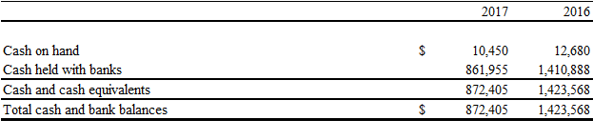

Term deposits having maturities of less than 3 months are a part of cash held with banks and earn interest rates between 1% to 2% per annum (2015 – 1.00% to 2.00% per annum).

**6. Accounts receivable**

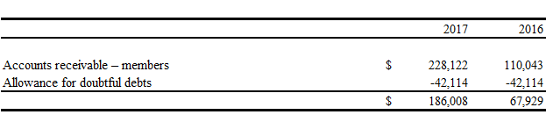

The aging of accounts receivable – members is as follows:

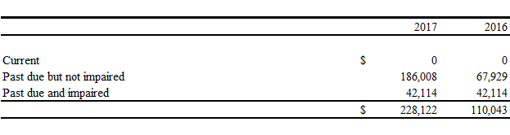

The movement in the allowance for doubtful debts was as follows:

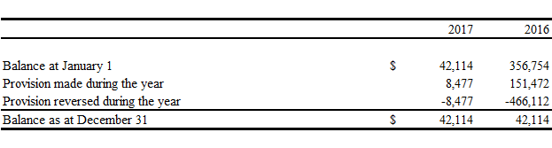

**7. Inventories**

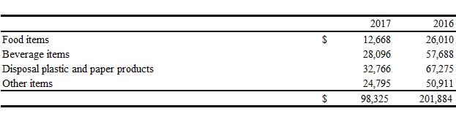

**8. Property and equipment, net**

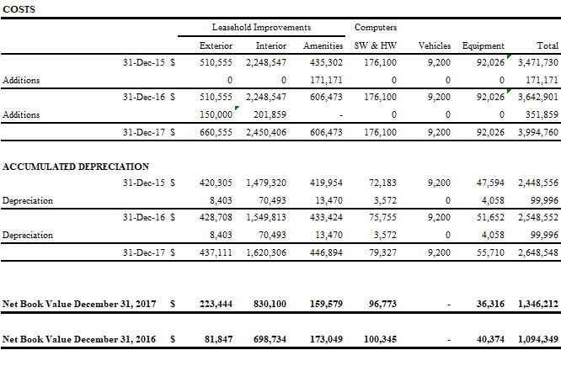

**9. Accounts payable and accrued expenses**

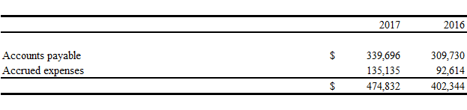

**10. Energy surcharge and credit card fee revenue**

The Club charges its members an energy charge of $100 (2016 - $100) per week when members stay at the Club. The Club also charges credit card revenue at the rate of 2.75% (2016-2.75%) for each credit card payment.

**11. Salary and benefits**

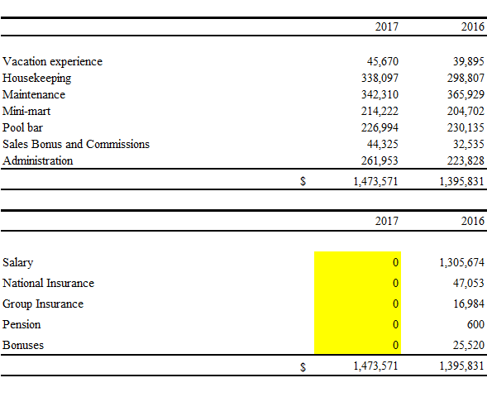

**12. Utilities**

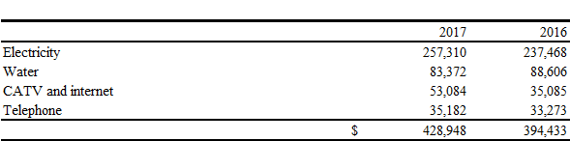

**13. Maintenance materials**

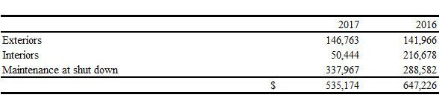

**14. Contracted services**

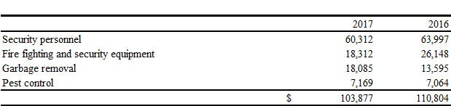

**15. Other supplies and materials**

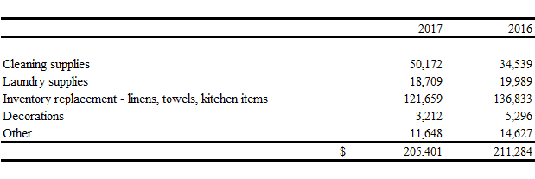

**16. Related party transactions**

Related party balances and transactions are shown below. Balances due from and/to related parties are interest-free and are without stated terms of repayments.

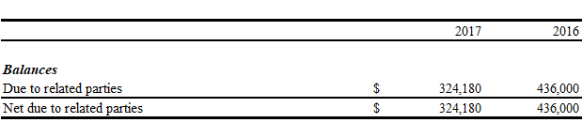

A loan was secured in the amount of $396,000 for a period of five years at 5% Interest, with monthly payments in the amount of $7,500.00 this was to take advantage of the remaining available balance on the duty free Concession which expired November 19th 2017, this is in lieu of a special assessment. The Duty Free Concession was extended during the year to December 31, 2020. [Tony to provide details]

**17. Management Compensation**

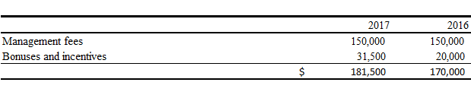

**18. Lease commitments**

On April 17, 2003, PIDL entered into a lease agreement with Marriott Ownership Resorts (Bahamas) Ltd. in its capacity as the Founder Member of the Club for and on behalf of the Club and its members effective January 1, 2003 for a term of 23 years. The property leased is to be used for the benefit of the members of the Club which now serves as the Welcome Centre. The Club’s commitments on this operating lease are as follows:

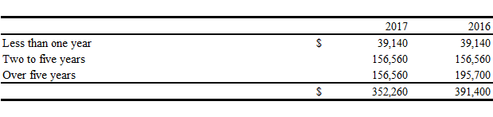

A portion of the above premises was sub-leased to other tenants on a month to month lease basis. The Club earned rental income of [$0 – Gloria to Confirm] during 2017 (2016 - $1,800) which was included in other income.

**19. Financial risk management**

There are a number of risks that are identified and managed on an ongoing basis. Among these risks, the more significant are market, credit and liquidity. The Club presents qualitative information about its exposure to risk and the objectives, policies and processes for measuring and managing these risks. Further quantitative disclosures are included throughout this note.

***(a) Market risk***

Market risk is the risk that future changes in market conditions such as foreign exchange rates and interest rates will affect the Club’s income or the value of its holdings of financial instruments. The objective of market risk management is to manage and control market risk exposures within acceptable parameters, while optimizing the return on risk.

The Company is not exposed to significant price risk as it does not invest in any equities and has minimum exposure to currency and interest rate risks.

Currency risk

All of the Company’s financial assets and liabilities are denominated in Bahamian dollars or in US dollars; therefore the Company is not normally exposed to significant currency risk.

Interest rate risk

Interest rate risk refers to the risk of loss due to adverse movements in interest rates. The Club’s interest rate risk arises from its cash held with banks including term deposits. The interest rate exposure at the reporting date is $680,542 (2016 - $670,432). As of December 31, 2017, interest rates on the cash held with banks are 0% to 1% per annum (2016 – 1% to 2%). [Gloria to Confirm]

***Interest rate risk,*** ***continued***

The Club believes that interest rate risk is minimal and a hypothetical 1% increase/decrease in the interest rate would have an impact of $6,800 (2016 - $6700) on the financial position and results of operations.

***(b) Credit risk***

Credit risk is the risk that a counterparty to a financial instrument will fail to discharge an obligation or commitment that it has entered into with the Club.

The Club’s maximum exposure to credit risk is as follows:

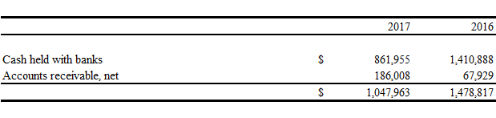

Management actively monitors the aging of receivables and establishes an allowance as circumstances warrant. The Club does not anticipate any losses in excess of the allowance for doubtful accounts as a result of this exposure.

Cash at bank amounting to $861,955 (2016 - $1,410,888) was deposited with regulated financial institutions. Accordingly management considers this to bear minimal credit risk.

***(c) Liquidity risk***

Liquidity risk is the risk that the Club will not be able to meet its financial obligations as they fall due. The Club’s approach to managing liquidity is to ensure, as far as possible, that it will always have sufficient liquidity to meet its liabilities and other commitments when due, under both normal and stressed conditions, without incurring unacceptable losses or risking damage to the Club’s reputation.

A maturity analysis of financial liabilities is as follows:

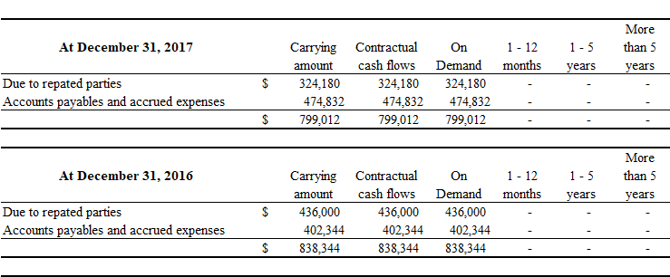

**20. Fair values of financial instruments**

The carrying values of financial assets and liabilities are considered to approximate their fair values due to the following reasons:

(a) immediate or short-term maturity; and/or

(b) interest rates approximate current market rates

The fair values of cash and cash equivalents, accounts receivables, accounts payable and accrued expenses are not considered to be materially different from their carrying values due to their short-term nature. Because of the interest-free nature and uncertainty surrounding the timing of the settlement of balances due to related parties, management is unable to estimate the fair value of these financial instruments.

**21. Capital management**

The Club’s main objectives when managing its capital are to safeguard its ability to continue as a going concern, to maintain adequate liquidity to meet obligations and to keep the property in an acceptable state of repair.

|  |  |  |  |  |  |  |  |  |  |  |  |
| --- | --- | --- | --- | --- | --- | --- | --- | --- | --- | --- | --- |
| **PARADISE ISLAND BEACH CLUB** |  |  |  |  |  |  |  |  |  |  |  |
| Statement of Financial Position |  |  |  |  |  |  |  |  |  |  |  |
| December 31, 2017 and 2016 |  |  |  |  |  |  |  |  |  |  |  |
| (Expressed in Bahamian dollars) |  |  |  |  |  |  |  |  |  |  |  |
|  | Note |  | 2017 | 2016 | Change 2017-2016 |  |  |  |  |  |  |
|  |  |  |  |  |  |  |  |  |  |  |  |
| **Assets** |  |  |  |  |  |  |  |  |  |  |  |
| **Current assets** |  |  |  |  |  |  |  |  |  |  |  |
| Cash and cash equivalents | 5, 19 | $ | 872,405 | 1,423,568 | (551,162.90) |  |  |  |  |  |  |
| Accounts receivable | 6, 19 |  | 186,008 | 67,929 | 118,078.98 |  |  |  |  | 67,928.82 | 28,464.00 |
| Inventories | 7 |  | 98,325 | 201,884 | (103,558.90) |  |  |  |  | (8,476.94) | (151,472.00) |
| Prepayments |  |  | 109,808 | 113,257 | (3,448.73) |  |  |  |  | 126,555.92 | 190,937.00 |
| Total current assets |  |  | 1,266,546 | 1,806,638 | (540,092.55) |  |  |  |  | 186,007.80 | 67,929.00 |
| **Non-current assets** |  |  |  |  | - |  |  |  |  |  |  |
| Property and equipment, net | 8 |  | 1,346,212 | 1,094,349 | 251,862.52 |  |  |  |  |  |  |
| Total non-current assets |  |  | 1,346,212 | 1,094,349 | 251,862.52 |  |  |  |  |  |  |
| Total assets |  | $ | 2,612,758 | 2,900,987 | (288,229.03) |  |  |  |  |  |  |
| **Liabilities and equity** |  |  |  |  | - |  |  |  |  |  |  |
| **Current liabilities** |  |  |  |  | - |  |  |  |  |  |  |
| Accounts payable and accrued expenses | 9, 19 | $ | 474,832 | 402,344 | 72,487.58 |  |  |  |  |  |  |
| Due to related parties | 16, 19 |  | 324,180 | 436,000 | (111,820.00) |  |  |  |  |  |  |
| Total current liabilities |  |  | 799,012 | 838,344 | (39,332.42) |  |  |  |  |  |  |
| **Non-current liabilities** |  |  |  |  | - |  |  |  |  |  |  |
| Maintenance fees paid in advance |  |  | 2,170,452 | 2,157,862 | 12,590.53 |  |  |  |  |  |  |
| Total non-current liabilities |  |  | 2,969,464 | 2,996,206 | (26,741.89) |  |  |  |  |  |  |
| **Equity** |  |  |  |  | - |  |  |  |  |  |  |
| Accumulated surplus (deficit) |  |  | -356,706 | -95,219 | (261,487.14) | 193,861 | 180 |  |  |  |  |
| Total deficit |  |  | -356,706 | -95,219 | (261,487.14) |  |  |  |  |  |  |
| Commitments | 18 |  |  |  | - |  |  |  |  |  |  |
| Total liabilities and equity |  | $ | 2,612,758 | 2,900,987 | (288,229.03) |  |  |  |  |  |  |
|  |  |  |  |  |  |  |  |  |  |  |  |
|  |  |  |  |  |  |  |  |  |  |  |  |
|  |  |  |  |  |  |  |  |  |  |  |  |
|  |  |  |  |  |  |  |  |  |  |  |  |
| Change in Accounts Receivable |  |  |  |  |  |  |  |  |  |  |  |
|  |  |  | 2017 | 2016 |  |  |  |  |  |  |  |
| Begin |  |  | 67,929 | 28,464 |  |  |  |  |  |  |  |
| Provisions |  |  | - | 314,640 |  |  |  |  |  |  |  |
| Changes in AR |  |  | 118,079 | (275,175) |  |  |  |  |  |  |  |
|  |  |  | 186,008 | 67,929 |  |  |  |  |  |  |  |
|  |  |  |  |  |  |  |  |  |  |  |  |
|  |  |  |  |  |  |  |  |  |  |  |  |
|  |  |  |  |  |  |  |  |  |  |  |  |
|  |  |  |  |  |  |  |  |  |  |  |  |
| The movement in the allowance for doubtful debts was as follows: |  |  |  |  |  |  |  |  |  |  |  |
|  |  |  |  |  |  |  |  |  |  |  |  |
|  |  |  | 2017 | 2016 |  |  |  |  |  |  |  |
|  |  |  |  |  |  |  |  |  |  |  |  |
| Balance at January 1 |  | $ | 42,114 | 356,754 |  |  |  |  |  |  |  |
| Provision made during the year |  |  | - | 151,472 |  |  |  |  |  |  |  |
| Provision reversed during the year |  |  | - | (466,112) |  |  |  |  |  |  |  |
| Balance as at December 31 |  | $ | 42,114 | 42,114 |  |  |  |  |  |  |  |
|  |  |  |  |  |  |  |  |  |  |  |  |
|  |  |  |  |  |  |  |  |  |  |  |  |
| Change in Provisions |  |  | - | 314,640 |  |  |  |  |  |  |  |
|  |  |  |  |  |  |  |  |  |  |  |  |
| **7. Inventories** |  |  |  |  |  |  |  |  |  |  |  |
|  |  |  |  |  |  |  |  |  |  |  |  |
|  |  |  | 2017 | 2016 |  |  |  |  |  |  |  |
| Food items |  | $ | 12,668 | 26,010 |  |  |  |  |  |  |  |
| Beverage items |  |  | 28,096 | 57,688 |  |  |  |  |  |  |  |
| Disposal plastic and paper products |  |  | 32,766 | 67,275 |  |  |  |  |  |  |  |
| Other items |  |  | 24,795 | 50,911 |  |  |  |  |  |  |  |
|  |  | $ | 98,325 | 201,884 |  |  |  |  |  |  |  |
|  |  |  |  |  |  |  |  |  |  |  |  |
|  |  |  |  |  |  |  |  |  |  |  |  |
|  |  |  | 2017 | 2016 |  |  |  |  |  |  |  |
|  |  |  | 12,668 | 26,010 |  |  |  |  |  |  |  |
|  |  |  | 28,096 | 57,688 |  |  |  |  |  |  |  |
|  |  |  | 32,766 | 67,275 |  |  |  |  |  |  |  |
|  |  |  | 24,795 | 50,911 |  |  |  |  |  |  |  |
|  |  |  | 98,325 | 201,884 |  |  |  |  |  |  |  |
|  |  |  |  |  |  |  |  |  |  |  |  |
|  |  |  |  |  |  |  |  |  |  |  |  |
| **5. Cash and bank balances** |  |  |  |  |  |  |  |  |  |  |  |
|  |  |  | 2017 | 2016 |  |  |  |  |  |  |  |
|  |  |  |  |  |  |  |  |  |  |  |  |
| Cash on hand |  | $ | 10,450 | 12,680 |  |  |  |  |  |  |  |
| Cash held with banks |  |  | 861,955 | 1,410,888 |  |  |  |  |  |  |  |
| Cash and cash equivalents |  |  | 872,405 | 1,423,568 |  |  |  |  |  |  |  |
| Total cash and bank balances |  | $ | 872,405 | 1,423,568 |  |  |  |  |  |  |  |
|  |  |  |  |  |  |  |  |  |  |  |  |
| **6. Accounts receivable** |  |  |  |  |  |  |  |  |  |  |  |
|  |  |  |  |  |  |  |  |  |  |  |  |
|  |  |  | 2017 | 2016 |  |  |  |  |  |  |  |
|  |  |  |  |  |  |  |  |  |  |  |  |
| Accounts receivable – members |  | $ | 228,122 | 110,043 |  |  |  |  |  |  |  |
| Allowance for doubtful debts |  |  | -42,114 | -42,114 |  |  |  |  |  |  |  |
|  |  | $ | 186,008 | 67,929 |  |  |  |  |  |  |  |
|  |  |  |  |  |  |  |  |  |  |  |  |
|  |  |  |  |  |  |  |  |  |  |  |  |
|  |  |  | 2017 | 2016 |  |  |  |  |  |  |  |
|  |  |  |  |  |  |  |  |  |  |  |  |
| Current |  | $ | 0 | 0 |  |  |  |  |  |  |  |
| Past due but not impaired |  |  | 186,008 | 67,929 |  |  |  |  |  |  |  |
| Past due and impaired |  |  | 42,114 | 42,114 |  |  |  |  |  |  |  |
|  |  | $ | 228,122 | 110,043 |  |  |  |  |  |  |  |
|  |  |  |  |  |  |  |  |  |  |  |  |
|  |  |  |  |  |  |  |  |  |  |  |  |
|  |  |  | 2017 | 2016 |  |  |  |  |  |  |  |
|  |  |  |  |  |  |  |  |  |  |  |  |
| Balance at January 1 |  | $ | 42,114 | 356,754 |  |  |  |  |  |  |  |
| Provision made during the year |  |  | 8,477 | 151,472 |  |  |  |  |  |  |  |
| Provision reversed during the year |  |  | -8,477 | -466,112 |  |  |  |  |  |  |  |
| Balance as at December 31 |  | $ | 42,114 | 42,114 |  |  |  |  |  |  |  |
|  |  |  |  |  |  |  |  |  |  |  |  |
|  |  |  |  |  |  |  |  |  |  |  |  |
|  |  |  |  |  |  |  |  |  |  |  |  |
|  |  |  |  |  |  |  |  |  |  |  |  |
|  |  |  |  |  |  |  |  |  |  |  |  |
| **9. Accounts payable and accrued expenses** |  |  |  |  |  |  |  |  |  |  |  |
|  |  |  |  |  |  |  |  |  |  |  |  |
|  |  |  | 2017 | 2016 |  |  |  |  |  |  |  |
|  |  |  |  |  |  |  |  |  |  |  |  |
| Accounts payable |  | $ | 339,696 | 309,730 |  |  |  |  |  |  |  |
| Accrued expenses |  |  | 135,135 | 92,614 |  |  |  |  |  |  |  |
|  |  | $ | 474,832 | 402,344 |  |  |  |  |  |  |  |
|  |  |  |  |  |  |  |  |  |  |  |  |
|  |  |  |  |  |  |  |  |  |  |  |  |